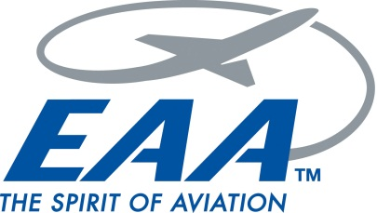

Experimental Aircraft Association

Chapter 501, Lincoln Park, New Jersey

MEMBERSHIP APPLICATION

THANK YOU for your interest in EAA Chapter 501! If you have not already done so, please join us at one of our monthly meetings. To join the Chapter as a Member, you must:
- Be a member of the EAA National Organization. EAA National Membership is $48 annually
- Pay annual Chapter 501 dues of $35 for an individual or $45 for a family membership.
- After July 1, dues for new members are prorated monthly. Make checks payable to “EAA Chapter 501.”

--- Each Membership of EAA Chapter 501 is subject to approval by the chapter board of directors ---

Name:

Home address:

Email address:

Preferred phone:

EAA National membership number:

How did you find out about EAA Chapter 501?

Are you in flight training or already licensed?

Please list applicable ratings:

If Aircraft owner or part of a flying club, please list aircraft type:

Applicant signature: Date:

Please email the completed application to Ian Azeredo (Membership Chairman) at ian.azeredo@gmail.com and Matt Lamm (Chapter President) at lamm.matthew@gmail.com

Questions: Contact any officer listed on our website at www.eaa501.org.

